# Results

1. Analysis of the genetic structure of the species

 Additional sequences obtained from GenBank (Benson et al., 2012) were added to analyze genetic distances and phylogenetic relationships

In addition to 75 *S. debilis* COI sequences obtained in the current study, 31 sequences obtained from GenBank (Benson et al., 2012) were added to analyze genetic distances and phylogenetic relationships. Among these samples, a high level of genetic homogeneity was found with two clades distinguished (see Figure 10). **The phylogenetic reconstruction shows that 96% of the COI sequences are grouped at one clade (Clade 1) with high supports (1/76 - Bayesian posterior probabilities/ ML bootstrap). This clade includes all the samples collected the in Northern and Southern Atlantic (68 and 7, respectively) and 27 individuals from the Indian Ocean.** A highly supported (0.98/76) sister clade **(Clade 2)** was formed by 4 samples of *S. debilis* collected in the Indian Ocean accompanied by a single specimen of *S. liui (GB NUMBER, REFERENCE)*. These 4 samples were assembled at the Northern coast of Madagascar at 1974 (Aznar-Cormano et al., 2015. Only one of the individuals collected off Madagascar in 1974 (KP759517) differed genetically from the others and fell into the major clade (Aznar-Cormano et al., 2015). Two COI sequences of the individuals collected in the Strait of Mozambique near the African coast in 2009 and uploaded into the GenBank by the same authors were also grouped into the main clade with the *S. debilis* samples from other areas.

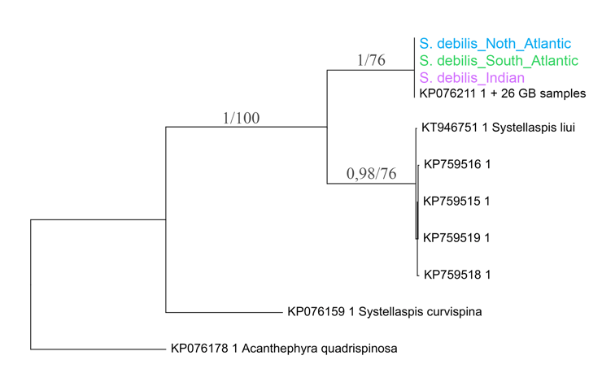

*Figure 10. Phylogenetic tree for the COI gene (539 bp) constructed by the maximum likelihood method for 106 individuals of S. debilis. The horizontal scale is the frequency of substitutions. Branch statistical supports: Bayesian posterior probabilities (left value) and ML bootstrap for 1000 pseudoreplicates (right value)*

The haplotype network of the COI sequences has a star-like structure and demonstrates the uniformity of the haplotypes from the North and South Atlantic, as well as those from the Indian Ocean. The diagram shows that most of the specimens from all three regions share the same haplotype, corresponding to the sample GU183793 from GenBank. Another three haplotypes are represented by 3 to 6 individuals which differ from each other and from the main haplotype by up to 2 substitutions. Moreover, these haplotypes are represented in the Atlantic and Indian Oceans. The second group corresponding to Clade 2 of haplotypes is less numerable and includes 4 haplotypes in couple with *S. liui*.

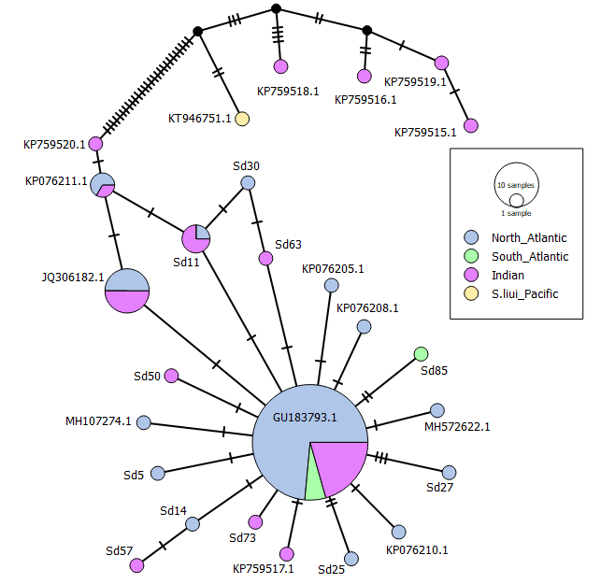

*Figure 11. Network of haplotypes for the COI gene, constructed by the Median Joining method. The sample consists of 107 individuals of S. debilis (68 in the North Atlantic, 7 in the South Atlantic, and 33 in the Indian Ocean), as well as one sample of S. liui.*

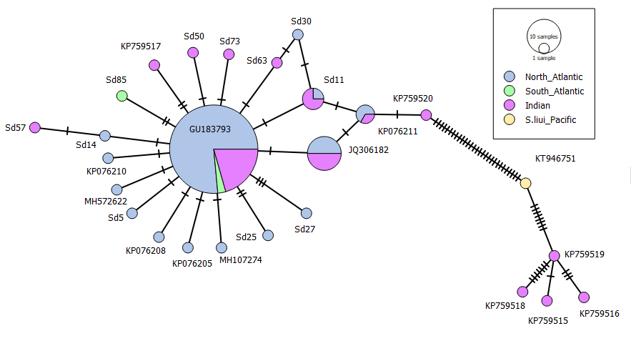

*Figure 11. Network of haplotypes for the COI gene, constructed by the Median Joining method. The sample consists of 106 individuals of S. debilis (70 in the North Atlantic, 3 in the South Atlantic, and 33 in the Indian Ocean), as well as one sample of S. liui.*

The Clade 1 nucleotide diversity (**0.0034±0.001) is** low in comparison with Clade 2 in couple with *S. liui (***0.0122±0.003).**

*Table 1. Data on genetic diversity of COI sequences in groups of S. debilis and a sample of S. liui (samples obtained in this work together with samples from GenBank)*

|  |  |  |  |  |
| --- | --- | --- | --- | --- |
| Group | **Number** | **Number** | **Haplotype  diversity (Hd±Sd)** | **Nucleotide  diversity (π±Sd)** |
| **of specimens** | **of haplotypes** |
| **Clade 2  *(S. liui)*** | **5** | **5** | **1.000±0.126** | **0.0122±0.003** |
| **Clade 1** | **102** | **32** | **0.735±0.046** | **0.0034±0.001** |
| North Atlantic | 70 | 21 | 0.661±0.004 | 0.0030±0.001 |
| South Atlantic | 3 | 3 | 1±0.272 | 0.0062±0.002 |
| Indian Ocean | 29 | 16 | 0.872±0.003 | 0.0042±0.001 |
| **In total** | **107** | **37** | **0.759±0.002** | **0.0091±0.002** |

The nucleotide homogeneity was Since no ITS-1 gene sequences were found in GenBank for the genus *Systellaspis,* nor for the family Oplophoridae, were compared *S. debilis* sequences with ones of the taxonomically closest organisms available in the database and the only representatives of the superfamily Oplophoroidea, *Ephyrina figueirai* (KJ155576.1) and *Acanthephyra pelagica* (KJ155571.1).The analysis of these sequences of the ITS-1 gene demonstrated a **high interspecific variability of the ITS-1 gene (Mean distance between species = 0.331) indicating the gene as low conservative in the superfamily Oplophoroidea. However, the gene sequences among *S. debilis* appeared to be nearly identical, with up to 11 substances, which raises the question about the marker’s informativity for the analysis of species structure.**

**Regarding the morphological analysis, we obtained no variance in 4 characteristics among 32, i.e. there were no** spinesarrangedintwoormorerows on the lateral side of the telson, while all the specimens bore scaphocerites on the lateralmargins of the antenna’s exopod. The other features occurred to be diverse, with the height of the carapace ranging from 5 to 9 cm and the length from 8.5 up to 14 cm among adult individuals. It does also worth to be noticed that of the four features suggested by (Sha and Wang, 2015) for distinguishing between *S. liui* and *S. debilis*, three were also characteristic of *S. debilis* (see Table 7) and only one morphological characteristic was not found in the specimens we studied – the presence of the numerous lateral spines on the telson arranged in two or more rows. However, this feature is not characteristic of representatives of the family Oplophoridae, and in this connection, it was suggested that the peculiarities of development of a particular individual, from which the species was described (Lunina, Kulagin, and Vereshchaka, 2018). The other three traits (the presence of a medial dorsal groove on the scaphocerite and the carina on the dorsal margin of the third abdominal somite, the movable spines on the pereiopods and the 3 teeth on the posterior margin of the fifth abdominal somite) were obtained in 26 to 100% of the *S. debilis* individuals.

*Table 2. Partitioning of variance.*

|  |  |  |  |  |
| --- | --- | --- | --- | --- |
| *Axis type* | Constrained | | Unconstrained | |
| **Axis** | **RDA1** | **RDA2** | **PC1** | **PC2** |
| **Eigenvalue** | 5.0983 | 0.2853 | 7.4947 | 3.6436 |
| **Proportion of Variance Explained** | **0.1728** | **0.0097** | **0.254** | **0.1235** |
| **Cumulative Proportion of Variance explained** | **0.1825** | | **0.3775** | |
| 0.56 | | | |

The RDA analysis was then performed to reveal (?) a relationship between the morphological traits and the sampling spot of the shrimps. With the length and height of the carapace chosen as the predictors the RDA model was statistically significant (ANOVA: **F = 7.3655, p = 0.0001**, number of permutations = 9999). The two canonical axes described 18% of the total variance, while the first non-canonical ones stood for 18% of it (see Table 4). That fact shows that 82% of the morphological variance is not related to the body size, whereby one-third of the residual variability is determined by PCA1 and PCA2.

The RDA model has demonstrated the correlation between the size of the body and some morphological traits, such as the number of the movable spines at ischium of the 5th pair of pereopods at the posteriorrow and the number of serrationsonlateralmargin of the 4th and 5th abdominal somites. Since for the correct analysis of morphological variability it is necessary to get rid of the influence of size on the traits, further work was based on the analysis of the residual RDA variability, i.e., noncanonical axes (see Fig. 13).

After excluding the influence of size, the features determining the most morphological variability of individuals, thus bearing the maximal species (?) scores were obtained. They included: the number of the movable spines at the anterior row at ischiums of 4th and 5th pairs of pereopods, the number of those at the anterior row of merus at the 3rd pereopod, the number of the teeth on the ventral side of the rostrum and the postorbital teeth on the dorsal side of the rostrum.

The first noncanonical axis (PC1) showed a significant relationship with the place of material collection (see Fig. 14). This relationship was statistically significant (ANOVA: F = 5.306, p = 0.0073). Specimens collected in the North Atlantic had, on average, lower PC1 values than those from the South Atlantic and the Indian Ocean. The described relationship of PC2 with the place of the collection was not detected (Fig. 12, ANOVA: F = 0.01, p = 0.99). The traits with the strongest relationship with PC1 and PC2 (see Fig. 13) show a clear relationship with the place of material collection (see Fig. 15).

For instance, it was found that the number of spines at the posterior row on the merus of the third pereopod and in the anterior row of the merus of the fourth pereopod were significantly higher in individuals collected from the Indian Ocean compared to those from other locations. At the same time, individuals from the Southern Ocean were found to have a higher average number of spines in the posterior row on the merus of the fourth pereopod than individuals from other geographic groups. The number of lateral serrationson the pleonon the left side of the fourth abdominal segment of the South Atlantic shrimp was slightly higher than that of individuals from the Indian Ocean. In the North Atlantic group, the average number of spines on the third and fourth pereopod was the lowest; the same applies to the number of teeth on the left side of the fourth segment.

To analyze the relationship between genetic and morphological characteristics of individuals, the Mantel test was conducted to assess the similarity of the two distance matrices (genetic distance matrix and distance matrix in the space of the first two non-canonical axes). The results of this test showed (r = 0.1791, p = 0.003, 9999 permutations) that there is a statistically significant similarity between the two matrices. **Thus, there is some correlation between the genetic and morphological characteristics of individuals.**

Что вставить?

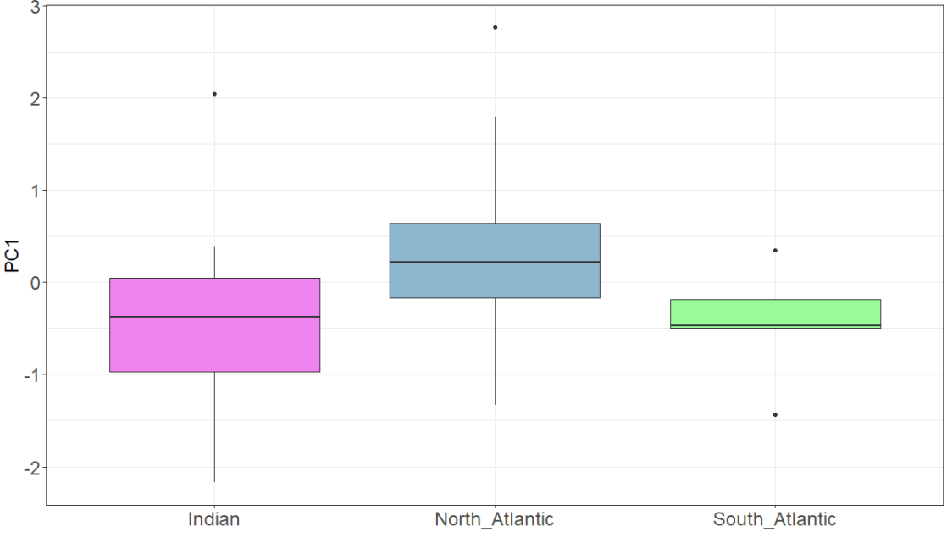 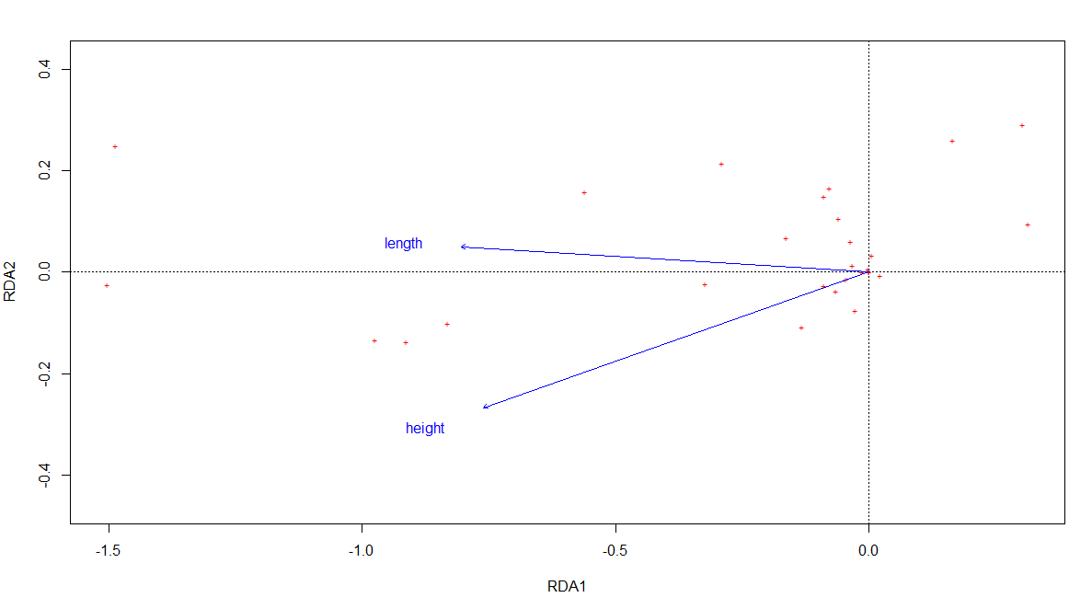

# Discussion

The fact that COI sequences from GenBank split into two clades was discussed back in (Sha, 2015) who attributed this fact to the presence of the distinct species (Sha, Wang, 2015). Specimens clustered together with *S. liui* and stored in the GenBank under the name *S. debilis* - KP76201, KP76202, KP76204, KP76205, KP76207, KP76208, KP76209, KP76211 - are proposed to be assigned to *S. liui* because the genetic distance separating the listed specimens from this species is less than 1.7% (Sha and Wang, 2015). The COI marker analysis, which revealed genetic distances between *S. liui* and *S. debilis* exceeding 5%, also led the authors of the article to conclude on the species status of *S. liui*. **However, due to the different rate of mutation accumulation among Decapoda, the genetic distances separating species can vary considerably from one family to another (Silva da et al., 2011). The degree of intraspecific variation is also variable: in some Decapoda species, intraspecific differences can exceed 5% (Silva da et al., 2011).**

The genetic homogeneity observed for both the COI and the ITS-1 genes **can be explained by 3 versions: 1) an ongoing gene flow resulting in a single panmictic (?) population despite the distances, hydrological and physical barriers between the habitats; 2) incomplete differentiation of the ancestral lines (Pérez-Barros et al., 2008) after a gene flow barrier formation because of the low evolutionary rate of the species and, less convincing, 3) the low evolutionary rate of both genes, as well as other markers available in the GenBank. If the evolutionary rate of *S. debilis* is that low indeed we could suppose that the gene flow possibly has stopped and in the opposite case, there should be an ongoing gene flow.**

**W**hether or not the gene flow still continues, it is important to **understand** it’s direction of the dispersal pathway of the ancestral form and the possible reasons for the cessation of the exchange of genetic material. The number of species of the genus *Systellaspis* inhabiting the Atlantic, Indian, and Pacific oceans (see Table 3) speaks in favor of the fact that *S. debilis* was dispersed to the Atlantic from the Indian Ocean. Moreover, of the 11 currently recognized species, 10 occur in the Pacific Ocean, 7 in the Indian Ocean, and only 6 in the Atlantic Ocean (<https://obis.org/taxon/107027>). That suggests that the center of biodiversity of the species (???) to have been the Pacific Ocean. It is also worth noting that, no endemic species of *Systellaspis* were noted for the Atlantic Ocean. **Consequently, the dispersal originated exactly from the Pacific Ocean, and the species gradually inhabited the Indian and Atlantic Oceans.**

The species dispersal could have happened whether by gene flow from the Indian to the Atlantic Ocean or in the opposite direction. However, the “Indian to Atlantic” route of the settlement is thought to be more common among marine organisms and the gene flow in this direction still takes place (Dudoit et al., 2018 MORE REFERENCES). **The colonization pathway from the Indian to the Atlantic Ocean through the equatorial waters** was restricted **in the West direction** after the collision of Africa and Eurasia ~13 million years ago and **in the East direction** by the separation of the Atlantic from the eastern Pacific by the rise of the Isthmus of Panama ~3.5 million years ago (Bowen et al., 2016). The hypothesis of the modern or recent colonization of the species route through the South Africa’s coast corresponds with the fact that **the Agulhas Current periodically directs circulations of warm water into the Atlantic (Hutchings et al., 2009). The alternative pathway** through the Drake Passage is characterized by low temperatures, which would be an obstacle to the settlement of warm-water shrimp. At present, the distribution of genetic lines between the Atlantic and Indian Oceans occurs through the currents that circle South Africa - the predominant ones being the cold Benguela Current moving northward along the west coast of Africa and the warm Agulhas Current moving southward along the east coast. Thanks to these currents, tropical species connectivity is maintained to this day (Dudoit et al., 2018).

*Table 3: Number of Systellaspis species found in the Atlantic, Indian and Pacific Oceans.*

|  |  |  |  |
| --- | --- | --- | --- |
| **Species / Ocean** | **Atlantic** | **Indian** | **Pacific** |
| *Systellaspis braueri* (Balss, 1914) | 1 |  | 1 |
| *Systellaspis cristata* (Faxon, 1893) | 1 | 1 | 1 |
| *Systellaspis curvispina* Crosnier, 1988 | 1 | 1 | 1 |
| *Systellaspis debilis* (A.Milne-Edwards, 1881) | 1 | 1 | 1 |
| *Systellaspis eltanini* Wasmer, 1986 | 1 | 1 |  |
| *Systellaspis guillei* Crosnier, 1988 |  | 1 | 1 |
| *Systellaspis intermedia* Crosnier, 1988 |  | 1 | 1 |
| *Systellaspis lanceocaudata* Spence Bate, 1888 |  |  | 1 |
| *Systellaspis liui* Sha & Wang, 2015 |  |  | 1 |
| *Systellaspis paucispinosa* Crosnier, 1988 |  |  | 1 |
| *Systellaspis pellucida* (Filhol, 1884) | 1 | 1 | 1 |
| **Total species number** | **6** | **7** | **10** |

However, when considering this scenario remains unclear the question of the species' inhabitation in the Atlantic Ocean at the time of repopulation of the genetic line now inhabiting it: in one case the ancestral line from the Indian Ocean displaced competitors, in the other - occupied a vacant ecological niche. The currently available facts are insufficient to dwell on one of the versions.

The revealed star-like haplotype structure of the species pattern is often interpreted as the result of a sharp growth of the population with a small number of its founders (bottle-neck effect) (Bucklin and Wiebe, 1998) after a catastrophic event. On this basis, the main clade possibly have emerged relatively recently and managed to spread over a huge water area due to the possession of some evolutionary/ecological advantage. In such a case, the gene flow, which **most likely originated from the Pacific and across the Indian Ocean to the Atlantic, ceased after the Eurasian-African connection**. **There is insufficient data to answer the question of whether genetic exchange between geographic groups from the Indian Ocean and the Atlantic is occurring nowadays.** Further genetic analysis using more sensitive evolutionary markers is needed.

At the same time, the haplotype network shows that the four samples from GenBank collected from Madagascar in 1974, as well as *S. liui* (together forming a sister clade on the phylogenetic reconstruction), differ from the main haplogroup by a significant (27 - 34 bp) number of substitutions. Moreover, all these samples have unique haplotypes that differ from each other by 1 to 8 substitutions. It is also interesting to note that the *S. liui* is separated from the main haplogroup by a smaller number of substitutions than the above samples from the Indian Ocean.

These 4 samples were collected in the Indian Ocean after 1974 was south of 20°S, affecting only one ecoregion, the Southern Indian Ocean (Table XXX – the sequences from GB). Since 4 of the 5 samples in 1974 were collected north of about 13°S, the barrier can be explained by abrupt changes in environmental parameters in the Central or Northern Madagascar region. It is possible that the range of the species is interrupted in the central part of Madagascar, and a genetic lineage close to *S. liui* or belonging to the same species resides near the northern part of Madagascar. The presence of one individual from the main clade despite on being collected from the northern part of Madagascar assumes that representatives of the main haplogroup are also distributed in the northern part of the Indian Ocean. Thus, we can assume that the two genetic lines or two species marked in the GeneBank as *S. debilis* are not only genetically, but also spatially (at least partially) separated as a consequence of the environmental features and/or ability of the lines to adapt.

The genetic diversity of individuals from the southern coast of Madagascar despite the small sample (5 individuals) suggests that the group of individuals inhabiting the northern part of the Indian Ocean is more ancient and ancestral. In this case, a large number of mutations would have had time to accumulate in the populations. Another situation is observed in the case of other specimens, with a star-like genetic structure of the species, which may be explained by the historical youth of the population - a sharp increase in the population size, which underwent a significant decrease in the number (bottle-neck) and further sharp increase in its number.

The formation of this group of haplotypes casts doubt on the hypothesis stated previously: the gene flow is unlikely to occur between groups that are so distant from each other, significantly differing in environmental parameters. The hypothesis suggests that the flow barrier in the Central Madagascar region leads to a more distinct population structuring than, for example, the barriers in the equatorial Atlantic region (REFS).

Thus, the sampling areas in the Atlantic Ocean are also in several mesopelagic ecoregions and capture several biogeochemical provinces, and are also separated by large oceanic gyres. Such conditions may create a barrier to the gene exchange between populations, which can lead to the isolation of the species (Norton and Goetze, 2013). The lack of the genetic structure among collected samples according to the version 1 should be ensured by two conditions: the absence of impenetrable barriers for the genetic flow in the communication pathway of groups from different oceans and the presence of a migration pathway of individuals from tropical latitudes of one ocean to the tropics of another within a short time.

**There are examples in the literature of poorly structured populations in far-flung areas of the Atlantic and Indian Oceans. For example, no genetic differences were found between populations of mesopelagic copepods from the Indian Ocean, South Atlantic, and tropical North Atlantic (Norton and Goetze, 2013).** The authors of the paper proposed several explanations for this fact: 1) the ongoing migration between the mentioned regions, 2) the relatively recent appearance of the barrier to gene flow that occurred in the past, or **3) colonization through the expansion of the range from one ocean to another (Norton and Goetze, 2013).** On the other hand, a number of non-ktonic predators, such as squids, have narrower populations or species ranges in the Atlantic Ocean (Fernández-Álvarez et al., 2020). Therefore, the ability to migrate for long periods of time does not always result in a free flow of genes.

The presence of two species occurring on different sides of the imaginary boundary around 20 degrees S in the central/northern part of Madagascar corresponding in position to the boundary between biogeochemical provinces or ecoregions according to some schemes of mesopelagic zoning (Longhurst, 2007; Reygondeau et al, 2013; Sutton et al., 2017). For example, (Sutton et al., 2017) east of Madagascar identifies three different ecoregions with significantly different environmental parameters (Sutton et al., 2017).

3. Verification of the taxonomic status of *S. liui*

The species *S. liui* has been described from a single female found in the Western Pacific (Philippine Sea) at a depth of 3360 m in the Indo-West Pacific (Sha, Wang, 2015). The fact that the mentioned individual was collected at a depth, exceeding the average depth of *S. debilis* (250-750 m) and other members of the genus *Systellaspis* may indicate the ecological characteristics of *S. liui* as a deep-water species. According to the species description, genetic and morphological differences between *S. debilis* and *S. liui* are sufficient to separate the species. However, the validity of the taxonomic status of *S. liui* is considered controversial (Lunina, Kulagin, and Vereshchaka, 2018).

**In order to verify the validity of the isolation of *S. liui* as a separate species, a comparison of intraspecific and interspecific genetic distances of the genus *Systellaspis* was carried out. The** genetic distances (number of base-to-site substitutions after averaging over all pairs of sequences within and between groups) between *S. liui* and *S. debilis* (clade1) from the Atlantic and Indian Ocean, obtained from GenBank, was compared with the interspecific distances between species of the genus *Systellaspis* showed that these groups are closely related, the percentage of difference 7%, while distances between other species of the genus *Systellaspis* are 8% or more (Table 5). At the same time, the distance between *S. liui* and the group *S. debilis* (clade 2), on the haplotype network falling with them in the same clade, was less than 2%. This insignificant distance is evidence in favor of individuals from clade 2 belonging to the species *S. liui*.

**Among other species, the smallest distance separates *S. braueri* and *S. paucispinosa* and is about 8%, the distance between *S. cristata* and *S. curvispina* also does not exceed 13%. In comparison with these results, the distance of 6.9% between the studied species, *S. liui* and *S. debilis*, differs only slightly, and therefore the differences may be considered sufficient to confirm the species status of *S. liui*.**

*Table 5. Intra- and intergroup genetic distances of COI gene of Systellaspis species. "S. debilis clade 1" corresponds to specimens from the Atlantic and Southern Indian Ocean, "S. debilis clade 2 (Ind.)" to grouping into one S. liui clade of specimens from the North Coast of Madagascar. Intragroup distances are marked in blue.*

|  |  |  |  |  |  |  |  |  |  |
| --- | --- | --- | --- | --- | --- | --- | --- | --- | --- |
|  | *S. braueri* | *S. cristata* | *S. curvispina* | *S. debilis* клада 1 | *S. debilis* клада 2 (Indian) | *S. guillei* | *S.*  *liui* | *S. paucispinosa* | *S. pellucida* |
| *S. braueri* | 0.1276 |  |  |  |  |  |  |  |  |
| *S. cristata* | 0.2352 | 0.1131 |  |  |  |  |  |  |  |
| *S. curvispina* | 0.2450 | 0.1276 | 0.0034 |  |  |  |  |  |  |
| *S. debilis* клада 1 | 0.3159 | 0.2945 | 0.2795 | **0.0040** |  |  |  |  |  |
| *S. debilis* клада 2 (Инд.) | 0.3139 | 0.2935 | 0.2738 | **0.0691** | **0.0106** |  |  |  |  |
| *S. guillei* | 0.2412 | 0.2242 | 0.2221 | 0.3180 | 0.2991 | NA |  |  |  |
| *S. liui* | 0.3156 | 0.2930 | 0.2751 | **0.0652** | **0.0159** | 0.2984 | NA |  |  |
| *S. paucispinosa* | 0.0814 | 0.2224 | 0.2340 | 0.2998 | 0.3026 | 0.2392 | 0.3055 | NA |  |
| *S. pellucida* | 0.2433 | 0.1897 | 0.1975 | 0.2962 | 0.2880 | 0.2099 | 0.2956 | 0.2309 | 7.1098 |
|  |  |  |  |  |  |  |  |  |  |

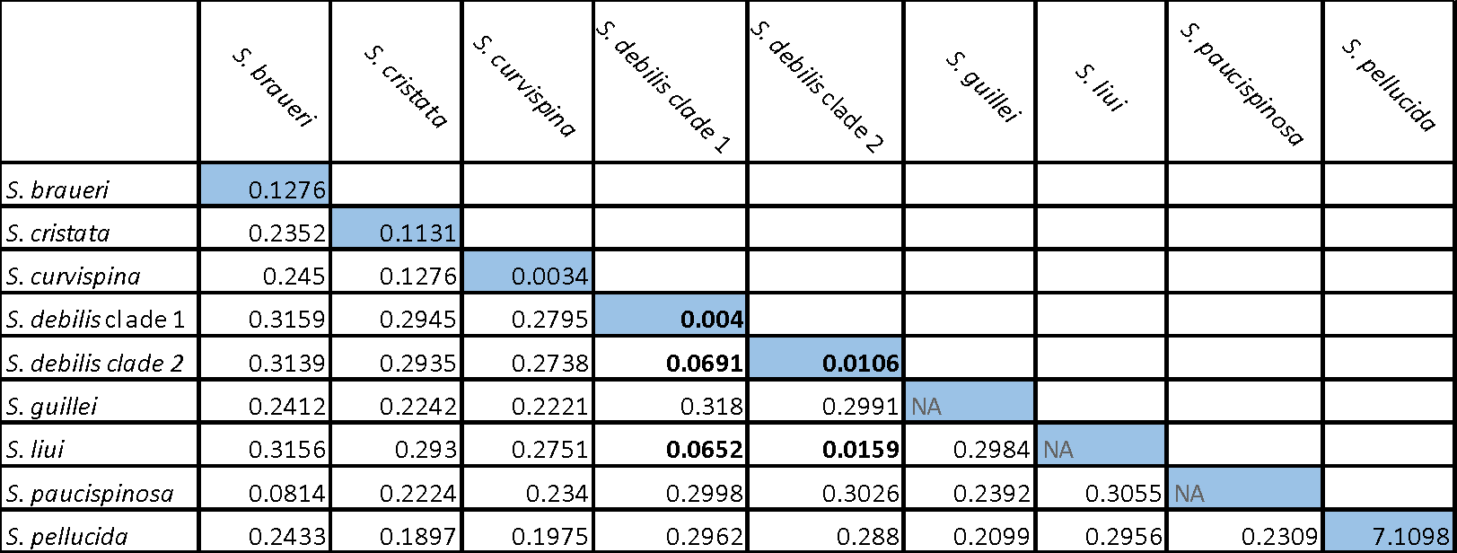

The inter- and intragroup genetic distances using COI marker in the *Systellaspis* genus were compared with those for the sister genus to *Systellaspis:* *Oplophorus* (see Table 6). The distances between the three species COI sequences available in the GenBank do not exceed 12%, with a minimum distance of 7.7% separating *O. gracilirostris* and *O. typus*. Such differences are also comparable to those between *S. liui* and *S. debilis.* The fact that the genetic differences between *S. liui* and *S. debilis* are comparable to the differences between other species of the genus *Systellaspis* and the closely related genus *Oplophorus* indicates the independent evolution of lineages over a long enough time to isolate independent species and, thus, **confirms *S. liui* status as an independent species.**

*Table 6: Intra- and intergroup genetic distances of Oplophorus species. Intra- and intergroup distances are shown in blue.*

|  |  |  |  |
| --- | --- | --- | --- |
|  | *O. spinosus* | *O. typus* | *O. gracilirostris* |
| *O. spinosus* | 0.0227 |  |  |
| *O. typus* | 0.1161 | 0.0227 |  |
| *O. gracilirostris* | 0.1062 | 0.0764 | 0.0215 |

The features that distinguish *S. liui* from the genetically and morphologically relative (?) *S. debilis* were Some of the morphological features of *S. liui* listed in the work of Zhongli Sha (Sha and Wang, 2015) turned out to be present in *S. debilis*. Of all 3 distinctive features proposed in the article to distinguish *S. liui* and *S. debilis*, 2 were also traits of *S. debilis*. Thus, all the individuals examined had a medial groove on the scaphocerite as well as a carina on the third somite. Among the differences listed only one morphological trait was not found in the specimens we studied – the disordered rows of small spines on the telson. Because of this feature is not common among the family Oplophoridae it may be the result of random mutations in a particular individual rather than an indicator of species divergence (Lunina, Kulagin, and Vereshchaka, 2018). As a high level morphological variability was observed in the samples of *S. debilis* in current and previous studies (Crosnier, 1987, MORE!), the validity (??? адекватность?) of the features turned out to be contraversive.

According to the concept of the unified approach to species delineation, species are the metapopulations that evolve separately from other genetic lineages (De Queiroz, 2007) and the separate evolution of lineages is supposed as the only necessary criterion for a species delamination (?) (De Queiroz, 2007). Other criteria of the species concept are considered secondary, but useful for confirming the existence of genetic differences between metapopulations. Morphological differences, ecological and embryonic traits can be counted as such "minor" differences. Apparently, the individuals collected off the North coast of Madagascar and grouped with *S. liui* in the same clade on the phylogenetic tree based on the COI gene belong to this species. **Thus, following the unified species concept (Queiroz De, 2007), *S. liui* is an independent species, but the morphological differences between this species and closely related species need to be reviewed.**

*Table 1. Data on genetic diversity of COI sequences in S. debilis groups (samples obtained in this work)*

|  |  |  |  |  |
| --- | --- | --- | --- | --- |
| Район | **Количество образов** | **Количество гаплотипов** | **Разнообразие гаплотипов (Hd±Sd)** | **Разнообразие нуклеотидов**  **(π±Sd)** |
| Северная Атлантика | 44 | 15 | 0.7000±0.006 | 0.0034±0.000 |
| Южная Атлантика | 7 | 7 | 1±0.006 | 0.0051±0.001 |
| Индийский океан | 24 | 11 | 0.786±0.007 | 0.0032±0.001 |
| **Итог** | **75** | **26** | **0.742±0.003** | **0.0033±0.001** |

*Table 2. Data on genetic diversity of COI sequences in groups of S. debilis (samples obtained in this work together with samples from GenBank)*

|  |  |  |  |  |
| --- | --- | --- | --- | --- |
| Region | **Number  of specimens** | **Number  of haplotypes** | **Haplotype diversity (Hd±Sd)** | **Nucleotide diversity (π±Sd)** |
| North Atlantic | 68 | 19 | 0.662±0.004 | 0.0030±0.000 |
| South Atlantic | 7 | 6 | 1±0.096 | 0.0046±0.001 |
| Indian Ocean | 31 | 18 | 0.888±0.002 | 0.0187±0.006 |
| In total | 106 | 36 | 0.755±0.002 | 0.0081±0.002 |

2 Analysis of morphological and genetic variability

*2.1 Results of RDA*

The results of Redundancy Analysis (RDA) showed a significant relationship between the matrix of morphological traits and the body size (the carapace length and height) (see Fig. 12). The RDA model was statistically significant (F = 7.3655, p = 0.0001, number of permutations = 9999). The two canonical axes together describe 18% of the total variance (see Table 4). The first two non-canonical axes describe a much larger proportion of the total variance, 37.8%. Thus, less than a quarter of the variability of morphological traits is explained by the relationship with body size. At the same time, about 80% of the variability of morphological traits is not related to size. At the same time, about one third of the residual variability is determined by PC1 and PC2.

~~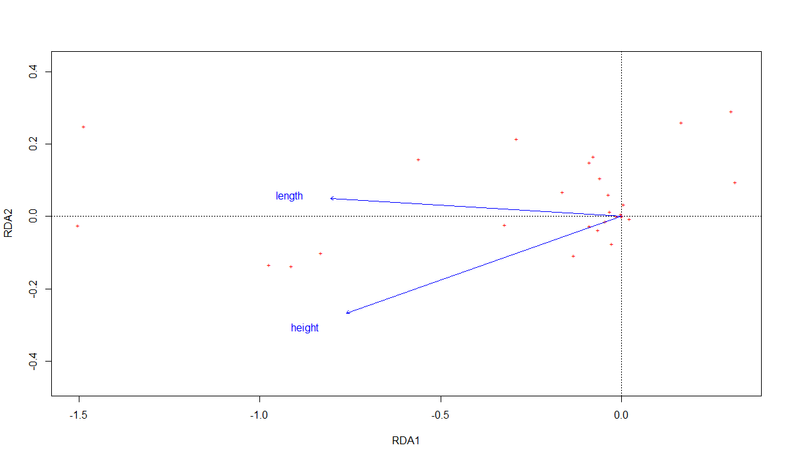~~

*Рисунок 12. Ординация признаков в пространстве канонических осей RDA1 и RDA2. Подписаны признаки с наибольшей нагрузкой по осям RDA1 и RDA2 (расшифровки см. в таблице 4)*

*Таблица 2. Вклад компонент в изменчивость.*

|  |  |  |  |  |
| --- | --- | --- | --- | --- |
| Тип осей | Канонические оси | | Неканонические оси | |
| **Ось** | **RDA1** | **RDA2** | **PC1** | **PC2** |
| **Собственное число** | 5.0983 | 0.2853 | 7.4947 | 3.6436 |
| **Доля объясненной дисперсии** | **0.1728** | **0.0097** | **0.254** | **0.1235** |
| **Накопленная доля объясненной дисперсии** | **0.1825** | | **0.3775** | |
| 0.56 | | | |

The RDA revealed the traits that have the strongest correlation with body size (Fig. 12, Table 4). These included: Number of lateral denticles on 4 segment (right side), Number of lateral denticles on 4 segment (left side), Number of bristles on the merus 4 segment in the posterior row.

Since for the correct analysis of morphological variability it is necessary to get rid of the influence of size on the traits, further work was based on the analysis of the residual RDA variability, i.e., noncanonical axes (see Fig. 13).

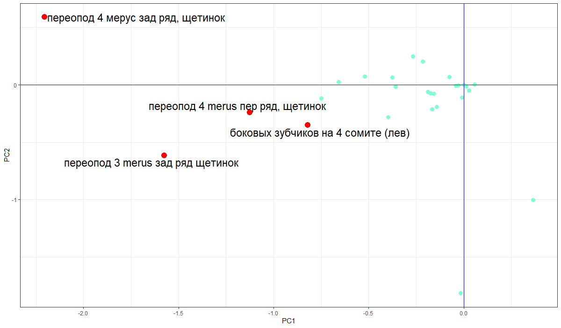

*Рисунок 13. Ординация признаков в пространстве неканонических осей PC1 и PC 2. Красными точками отмечены признаки с высокими факторными нагрузками (независимые от размера карапакса), светло-голубым – признаки с меньшими факторными нагрузками (зависимые от канониче*

The RDA revealed the traits that have the strongest correlation with body size (Fig. 12, Table 4). These included: Number of lateral denticles on 4 segment (right side), Number of lateral denticles on 4 segment (left side), Number of bristles on the merus 4 segment in the posterior row.

Since for the correct analysis of morphological variability it is necessary to get rid of the influence of size on the traits, further work was based on the analysis of the residual RDA variability, i.e., noncanonical axes (see Fig. 13).

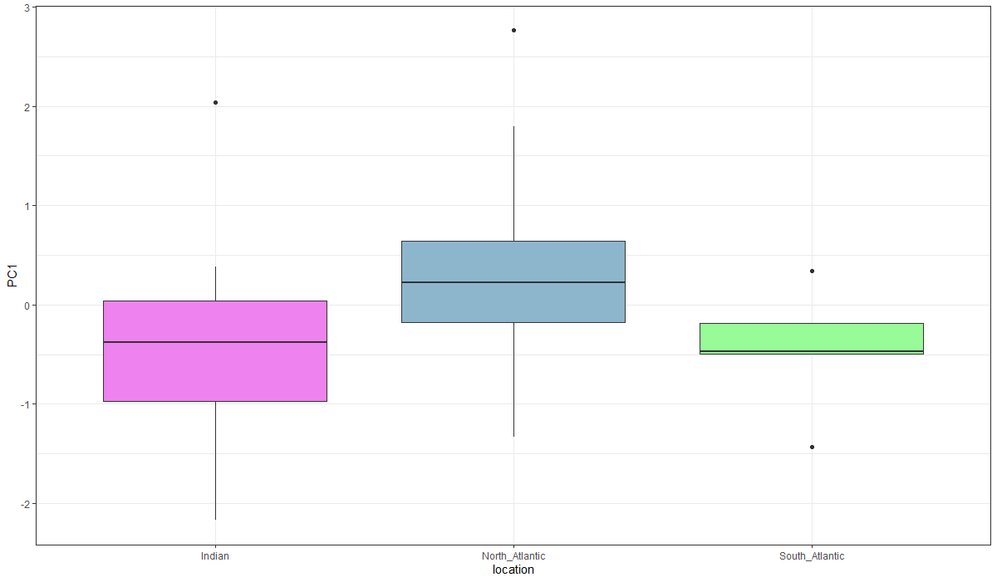

*Рисунок 14. Изменчивость особей из Индийского океана, Северной и Южной части Атлантического океана вдоль неканонической оси PC1*

The PC1 and PC2 loads (see Table 4) had the following features:

1. Number of bristles on merus 4 overpods in the posterior row,

2. Number of bristles on merus 3 overpods in the posterior row,

3. Number of bristles on merus 4 repos in the front row,

4. Number of lateral teeth on left side of 4 somites,

These characters determine the maximum morphological variability of individuals, while excluding the influence of size.

The first noncanonical axis (PC1) showed a significant relationship with the place of material collection (see Fig. 14). This relationship was statistically significant (ANOVA: F = 5.306, p = 0.0073). Specimens collected in the North Atlantic had, on average, lower PC1 values than those from the South Atlantic and the Indian Ocean. The described relationship of PC2 with the place of collection was not detected (Fig. 12, ANOVA: F = 0.01, p = 0.99).

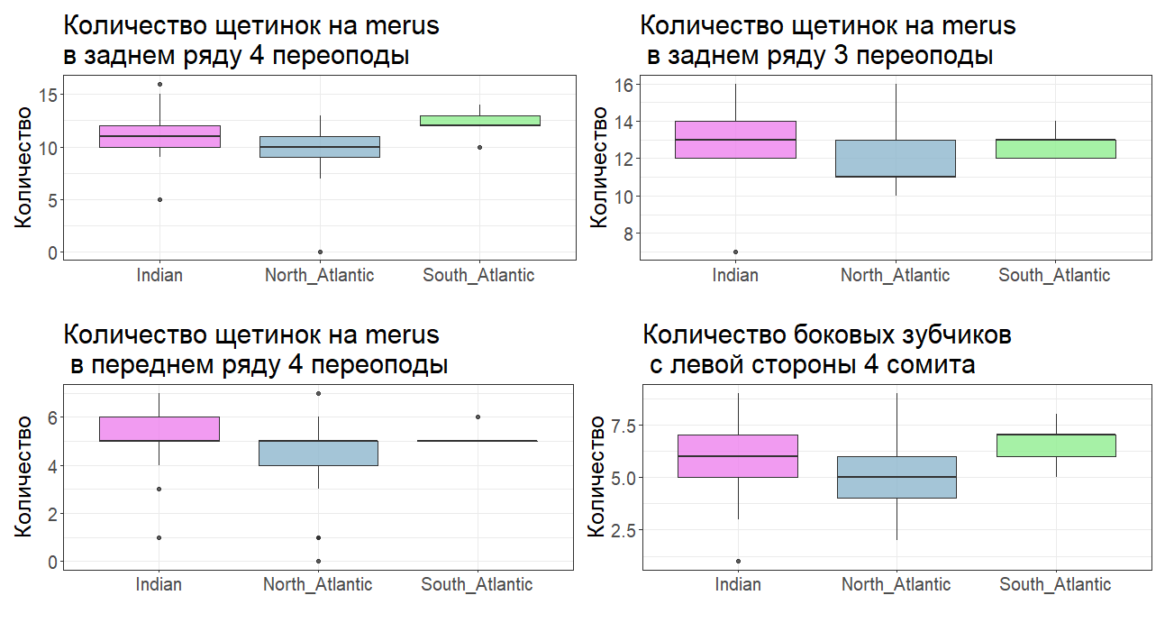

*Рисунок 15. Вариабельность значений признаков среди особей из Северной и Южной Атлантики и Индийского океана*

The traits with the strongest relationship with PC1 and PC2 (see Fig. 13) show a clear relationship with the place of material collection (see Fig. 15). Thus, the number of bristles in the posterior row on the merus third and in the anterior row of the merus fourth copepod was, on average, higher in individuals collected in the Indian Ocean than in individuals from other locations. At the same time, individuals from the Southern Ocean were found to have a higher average number of bristles in the posterior row on the merus of the fourth pereopod than individuals from other geographic groups. The number of lateral denticles on the pleura on the left side of the fourth segment of the South Atlantic shrimp was slightly higher than that of individuals from the Indian Ocean. In the North Atlantic group, the average number of bristles on the third and fourth pereopod measures was the lowest; the same applies to the number of teeth on the left side of the fourth segment.

2.2 Comparison of the results of genetic and morphological analyses

Before comparing the results, the genetic data were interpreted as follows: the individuals for which the COI gene sequences were obtained were divided into two groups, the first of which was genetically identical to each other for this gene ("main haplogroup") and the second group differed from the first group by the presence of one or more substitutions ("has mutations"). This division is visualized as a haploset (see Fig. 11).

There were no statistically significant differences between PC1 and PC2 in the individuals of these two groups (t-test, PC1: t = 1.0637, p = 0.2945; PC2: t = 1.4749, p = 0.1455). However, the PC1 values in the main group had clearly less scatter than the scatter of values among individuals carrying mutations (see Fig. 16).

The absence of nonmutant individuals from the South Atlantic in the analysis is explained by the fact that the main haplogroup contained juvenile individuals, which were removed from the morphological analysis.

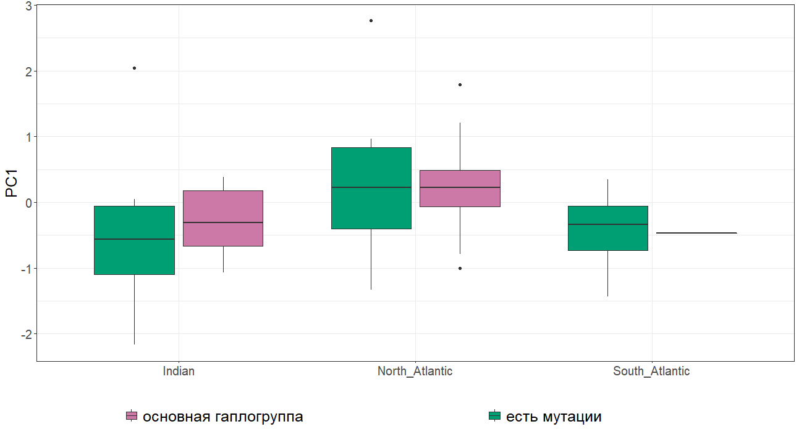

*Рисунок 16. Изменчивость особей из основной гаплогруппы по COI и мутантных особей вдоль оси PC1 в зависимости от локации*

The representatives of the two genetic groups show no pronounced segregation in the PC1 and PC2 space (see Fig. 17). However, it can be noted that individuals from both groups from the Indian Ocean are shifted towards lower PC1 values compared to individuals from the North Atlantic. Thus, we can conclude that in the North Atlantic some specimens morphologically differ from shrimps from the Indian Ocean. At the same time, it should be noted that some individuals from these locations are morphologically similar. Thus, morphological markers do not show a clear relationship with the two genetic groups, but are clearly associated with the collection areas.

It should be noted that the two distinguished groups "main group" and "individuals carrying mutations" were distinguished rather formally. Therefore, for a more subtle analysis of the relationship between genetic and morphological characteristics of individuals, the Mantel test was conducted, which allowed us to evaluate the similarity of two distance matrices (genetic distance matrix and distance matrix in the space of the first two non-canonical axes).

The results of this test showed (r = 0.1791, ppermutational = 0.003, 9999 permutations) that there is statistically significant similarity between the two matrices. Thus, there is some correlation between genetic and morphological characteristics of individuals.

# To methods

It should be noted that during the initial processing of the obtained sequences, double peaks were visible in some chromatograms. This can be explained by heteroplasmy or the presence of numts found in the mitochondrial genome of decapods (Iketani et al., 2021). If double peaks were detected, a closer comparison of the forward and reverse reads was performed and the higher peak was selected, based on which the nucleotide value was also edited for the corresponding base.

Про ITS-1

There were problems during sequence processing due to the presence of heterozygotes; in such cases, nucleotides were labeled according to the standard code.

Results - 2 страницы с картинками  
Discussion - 3 страницы